**Introduction** – A financial analysis report shows the financial performance of your business over a specified period of time, usually on a quarterly or yearly basis. It's like a medical report but for your business's financial health.

**Key Findings** - In the given project, we were given with a data where we need to find out the Annuity, EMI, Beginning Balance, Interest, Ending balance, Term Loan, IRR, NPV, Cash Flow etc.

**Methodologies** –

Annuity- A contract between you and an insurance company that requires the insurer to make payments to you, either immediately or in the future. You get a fixed amount of money for the rest of your life in return for a lump sum payment or a series of instalments.

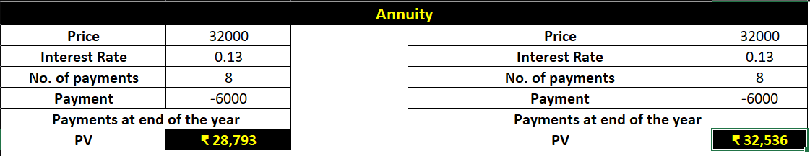

**Insights**- We can calculate the Interest per month with reference of Rate per month, number of payments along with months, PV & FV. If you make the payment now, you need to pay 32,000 of present value. If you opt for yearly payments with payment at the end of the year, you need to pay 28, 793 of present value. If you opt for yearly payments with payment at the end of the year, you need to pay 32,536 of present value. You can clearly see that option 2 is beneficial for you.

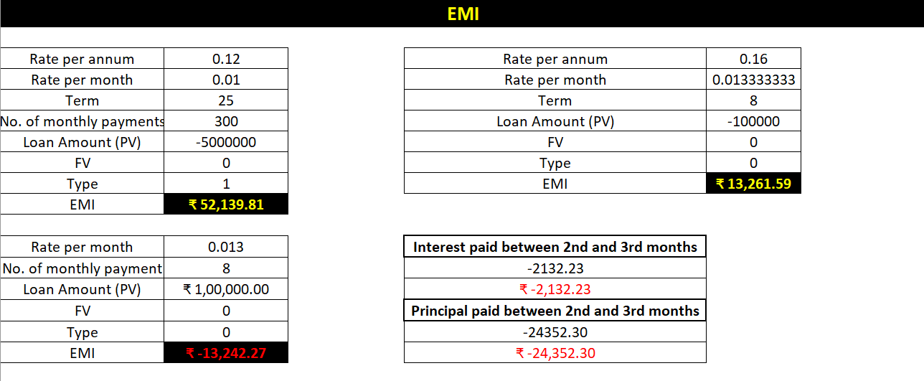

Present Value (PV) is the loan amount. Future Value (FV) is 0 as at the end of the term the loan amount

should be 0. EMI includes both-interest and a part payment of principal. As the time increases, these two components of EMI will vary, reducing the balance.

**Actionable –**  if you have taken a loan of 1,000,000 for a term of 8 months at the rate of 16% per annum. the decreasing interest amounts, the increasing payment of principal amounts and the diminishing loan balance over the 8 months. At the end of 8 months, loan balance will be 0.

Suppose you take a loan of 100,000 and you want to pay back in 15 months with a maximum monthly payment of 12000. You might want to know the interest rate at which you have to pay.

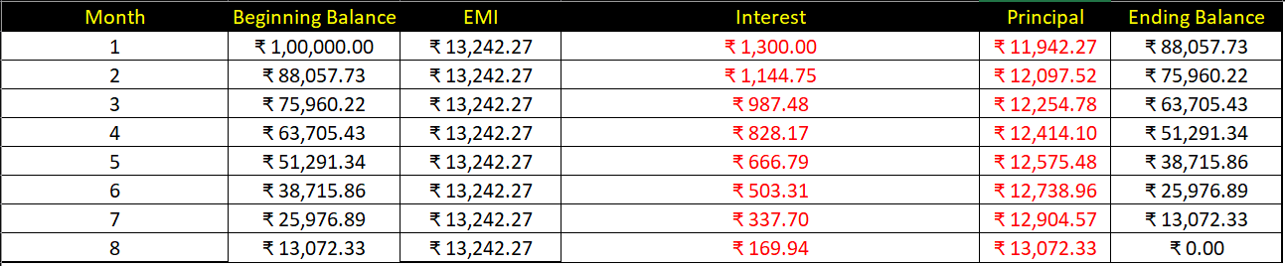

cash flows occur at the beginning of every year. In such a case, you should not include the first cash flow in NPV calculation as it already represents the current value. You need to add the first cash flow to the NPV obtained from rest of the cash flows to get the net present value.

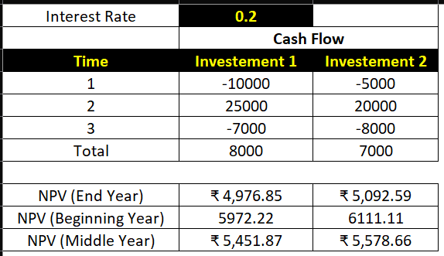

**IRR -** Internal Rate of Return (IRR) of an investment is the rate of interest at which NPV is 0. It is the rate value for which the present values of the positive cash flows exactly compensate the negative ones. When the discount rate is the IRR, the investment is perfectly indifferent.

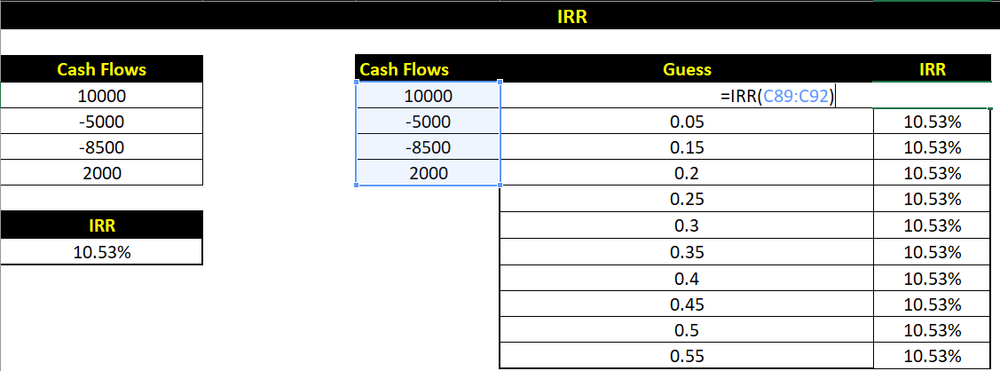

**Conclusion**- reviewing financial statements before making important decisions is important because these documents offer a comprehensive snapshot of a company's fiscal health and performance.